INF1009 Object Oriented Programming [2024/ 25 T2]
Interim OOP Report
LAB P4-2
Professor: Lim Yishun Jerry
Name | Student No.
Cheong Wei Loong | 2402219
Brian Lee ZheXian | 2400873
Lee Jing Wen | 2402749
Abbie Ng Xin Yi | 2402577
Daryl Ang Chen Kai | 2401329
Andrade Dan Aaron Estrella | 2400996

Table of Contents
INF1009 Object Oriented Programming [2024/ 25 T2] 1
Table of Contents 2
Executive Summary 3
Abstract Engine Implementation 4
Scene Management 4
Entity Management 4
Specific Entity Implementations 5
Collision Management 5-6
Collision Implementations in Engine
Movement Management 6-7
Movement Behavior for Different Entities
Input/Output Management 7
Input Handling for Different Entities
System Architecture 8
UML Diagram 8
Object-Oriented Programming (OOP) Principles 9
Encapsulation 9
Abstraction 9
Polymorphism 9
Inheritance 9
Maintainability 10
Reusability 10
Scalability 10
Reflection on limitations with the engine design(overall and some specific) 10-11
Team Contributions 13

Abstract
This report outlines the implementation of an abstract game engine, focusing on key system components such as scene management, entity management, collision handling, movement control, and input/output (I/O) processing. The engine is designed using object-oriented programming (OOP) principles to ensure modularity, scalability, and maintainability.
Scene management is handled through a ScreenManager, which keeps track of different game screens in one place, making it easy to switch between menus, gameplay, and other scenes. The Entity Manager organizes game objects (like players, obstacles, and doors) using a structured system that allows them to interact smoothly. The Collision Manager detects when objects bump into each other and decides how they should respond. The Movement Manager controls how objects move, making sure movement feels natural and smooth. Finally, the I/O Manager processes player actions, like keyboard and mouse inputs, to allow interaction with the game.
The report also discusses key OOP principles such as encapsulation, abstraction, inheritance, and polymorphism, highlighting their role in enhancing code reusability and efficiency. Additionally, limitations in the current design, including basic collision detection and limited UI capabilities, are identified, with proposed improvements such as integrating Box2D for physics-based interactions.
Overall, this abstract engine provides a foundational framework for game development, offering an adaptable and scalable structure that can be expanded to accommodate more complex gameplay mechanics.

Abstract Engine Implementation

Scene Management
Scene management is a crucial aspect of game development that allows seamless transitions between different parts of a game, such as menus, gameplay, and pause screens.
In our case, scene management can be implemented using a SceneManager class that handles different game states through Screens.
In our abstract engine, we have utilized the ScreenManager.java and the MenuScreen.java ScreenManager which is implemented as a singleton that stores and manages LibGDX Screen instances in a HashMap. During initialization, each screen (such as the MenuScreen and PlayScreen) is created and added to the map, allowing you to quickly retrieve and switch between them by name. When showScreen is called, the manager disposes of the currently active screen (if any), updates the currentScreen reference, and sets the new screen on the main game instance. A dispose method also provides a centralized way to dispose of all screens at once, ensuring resources are properly freed. The overall result is a convenient, centralized mechanism for screen management in your game.
Whereas, The MenuScreen class provides a simple, text-based menu interface for your LibGDX game. It initializes an orthographic camera and a SpriteBatch to handle rendering. A background image such as i.e (MENU_Background.jpg) and a default bitmap font are loaded in the init() method, along with two button regions—one for “PLAY” and one for “EXIT.” In the render(float delta) method, it draws the background, a title (“My cool Game”), and the two button labels. User interactions are handled by translating touch or mouse coordinates to the camera’s coordinate system, then checking if the touch point lies within either button’s bounding box. Tapping the “PLAY” button triggers a screen switch via ScreenManager, while tapping “EXIT” calls Gdx.app.exit() to close the application. All associated resources (batch, background, font) are disposed of when the screen is no longer needed.

Entity Management
Entity Management is a core feature of an abstract engine, responsible for creating, updating, and organizing game objects efficiently. The Entity Manager is responsible for handling the lifecycle of entities, allowing seamless interaction between different game objects while maintaining modularity and performance.
Our entity system follows an Entity-Component design pattern, where each entity encapsulates essential attributes such as position and dimensions but delegates behaviour to specific components or interfaces. This improves reusability and flexibility. This abstraction allows different entity types such as Player, Door, Obstacles and Walls to inherit and implement their own behaviours.
The base Entity class defines core properties and handles attributes that are common to each entity subclass, allowing each subclass to set its position and size dynamically. The Entity Manager maintains a list of active entities and provides methods to add and remove entities dynamically during runtime, update all entities every frame to ensure proper logic execution, render entities for accurate display, and integrate with the Collision Manager to detect interactions. Additionally, it removes unnecessary objects, such as obstacles that disappear after collisions, to optimize memory usage. The EntityManager class maintains an array of entities and provides core methods for lifecycle management. The add_entity() and remove_entity() methods ensure that collidable entities are automatically registered with the CollisionManager, improving efficiency. The update() method iterates through all entities, dynamically calling their update() method, while render() ensures all entities are drawn without manual intervention. A filtering mechanism through getEntitiesByType() enables efficient retrieval and manipulation of specific objects.

Specific Entity Implementations
- Player: The player entity is controlled by user input. It checks for collision with any collidable object and is unable to move past them. The player interacts with objects in the environment, such as doors and obstacles, triggering specific behaviours.

- Door: The door entity acts as a transition point between screens. When the player collides with a door, it triggers a method that transitions to the next screen. Each door is created with an attribute specifying which screen it will move to upon interaction.

- Obstacles: These are moving entities that interact with the player and the environment. They are continuously in motion and check for collisions. If an obstacle collides with a wall, it reverses direction. If it collides with the player, the obstacle disappears, and a text message appears indicating the interaction.

Collision Management
Collision management is a crucial component of our abstract engine, ensuring entities interact meaningfully within the game environment. The collision manager handles the detection and resolution of collisions between objects. Collision detection ensures realism, physics accuracy, and game interactions. Having a scalable and reusable collision system can help handle thousands of objects effectively and efficiently. It can also be used across multiple games and engines.
A robust collision system consist of 3 things:
- Collision Detection → Checking if objects overlap or interact.
- Collision Response → Handling object interactions (stopping, bouncing, triggering events).
- Collision Optimization → Improving performance through efficient algorithms.
In our abstract engine uses the ICollidable interface, which provides methods for collision detection checkCollision(), to determine if two entities have intersected based on their bounding boxes or shapes and collision response handleCollision() to define how entities react upon collision, such as stopping movement or triggering game logic. The CollisionManager maintains a dynamic list of ICollidable objects, updating it as entities are created or removed. registerEntities() method is used for collision detection, collecting all entries that implement ICollidable and adding them to the collidable list. detectAndHandleCollisions() method is used to iterate through all registered entities, to handle collision handling, where upon detecting a collision, each involved entity’s handleCollision() method is invoked to apply a specific response.

Collision Implementations in Engine
- Player & stationery entities: Main moving entity colliding with brown rectangle (Door) transiting to another scene. Main entity colliding with stationary walls causing a stop in movement response and not passing through.

- Game Object: Main moving entity colliding with another entity (Object) causing a collision and for one entity to stop moving.

- Moving Object: The main moving entity collides with another moving entity (object), causing the object entity to disappear and a message indicating an intersection.

Movement Management
Movement management is a crucial component of our engine, ensuring that entities, particularly the player, can navigate the game world smoothly and responsively. The Movement Manager handles movement calculations and velocity updates, ensuring smooth transitions while restricting movement when necessary.
The Movement Manager uses an acceleration-based movement system, where an entity’s velocity is updated based on user input and capped at a defined maximum speed.
The calculateMovement() method processes user input for movement, to ensure that the player can move in response to keyboard input while keeping movements within the defined speed limits.

Movement Behavior for Different Entities
- Player: Move based on player input but are restricted from moving past walls and obstacles.
- Obstacles: Move autonomously, reversing direction upon colliding with walls.

Input/Output Management
The Input/Output (IO) Manager is responsible for handling user interactions, ensuring smooth communication between the player and the game world. It processes keyboard inputs, mouse interactions and button press to allow the player to control their in-game character and interact with objects effectively.
The IO Manager ensures that only one instance manages all inputs. The class maintains a mapping of key states and processes both keyboard and mouse interactions. In our abstract engine, keyboard inputs are tracked using a HashMap.This allows for easy retrieval of key states during gameplay. The keyDown() and keyUp() methods update the map dynamically. The IO Manager also tracks mouse interactions, including button presses and position updates using mouseMoved().

Input Handling for Different Entities
- Player: Uses keyboard input for movement and actions. The IO Manager detects key presses and updates movement accordingly.
- UI Interactions: Mouse inputs allow interaction with menus, buttons, and other UI elements.
- Game Objects: Specific objects in the game world may respond to input.

System Architecture

UML Diagram
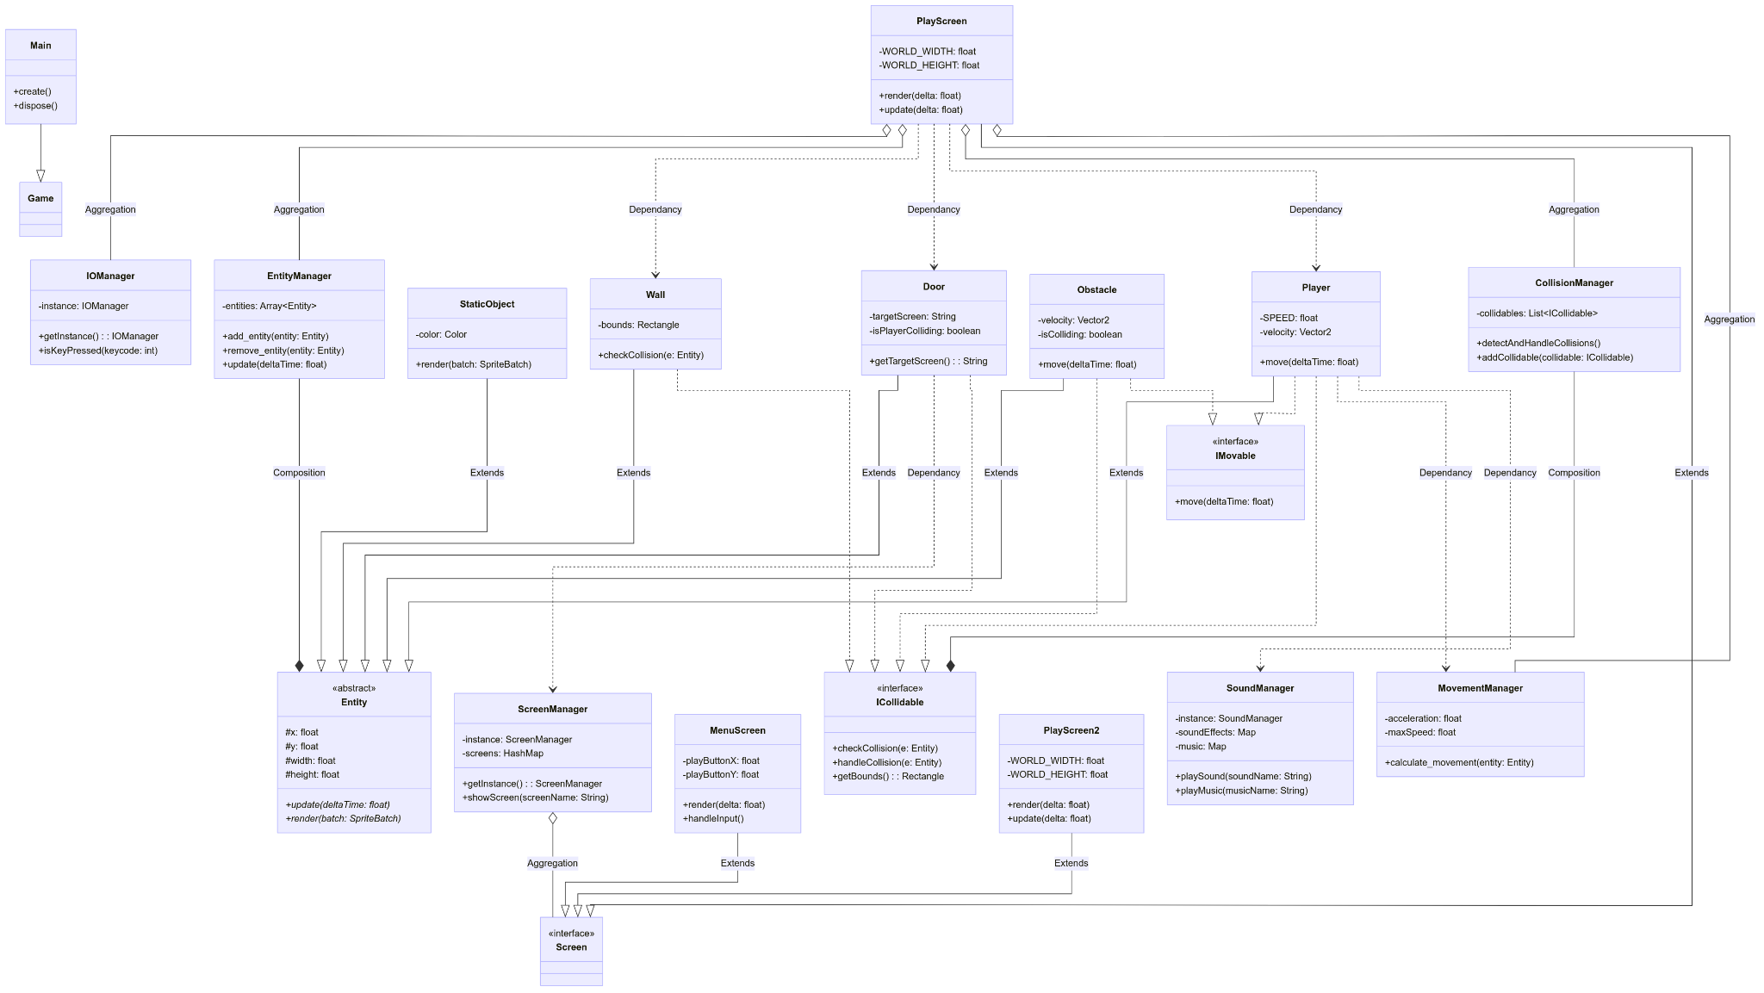
Fig 1. UML Diagram

Object-Oriented Programming (OOP) Principles

Encapsulation
Encapsulation is important as it ensures internal data and implementation details of a class are hidden from external access. When writing our code, we wanted to ensure that we adhered to this principle. Therefore, we made sure that attributes specific to an entity are not publicly accessible by any part of the code, but they are able to receive necessary information through the setter and getters within our code. Additionally, the array of all the entities created is private, but they can still call public methods to interact with the array.

Abstraction
High-level interfaces define behaviour, while concrete implementations provide functionality. This allows for interchangeable subsystems, enabling flexibility in choosing or replacing system components without affecting other parts of the engine. To that end, we implemented the interfaces IMovable and ICollidable that define if an entity is movable or affected by collision without writing the code into each entity. Instead, any entity is able to exhibit such behaviours by implementing the interfaces. Additionally, our screens and entities employ the use of abstract methods for commonly used methods such as update, render or dispose to keep processes standardised while not revealing implementation methods.

Polymorphism
Polymorphism allows objects of different classes to be treated as objects of a common base class, enabling flexibility in system design. We have utilized run-time polymorphism with method overriding with several of our classes. For example, while our Player class inherits the render method from the Entity parent class, they employ specific rendering methods when initialized which give the Player class their characteristic behaviors.

Inheritance
Through our programming methodology of the entities, you can see that we use inheritance in order to create a proper structure where the Entity class is the parent class for all the different Entities, which then inherit common attributes such as position (x,y) and width and height. By organising our code this way, it becomes easier to programme new entities in the future as needed, and for all potential contributors to the project to easily read the intent of each class.

Maintainability
Maintainability in an abstract engine refers to the ease with which the engine can be modified, extended, debugged, and updated over time without introducing unintended side effects or requiring complete overhaul. In designing an abstract engine, maintainability is crucial. A well-structured engine is one that is easy to modify, expand, and debug over time. The key to achieving this is having a Modular design code. By embracing modular design, we create an engine that is not just powerful, but also future-proof and easy to maintain.

Reusability and Scalability
By using inheritance and polymorphism, we ensure that code can be extended and adapted without rewriting functionality. The use of abstract base classes allows different components to share common behaviors while enabling modifications and extensions in a structured way. This approach minimizes code duplication and accelerates the development process, allowing us to easily create new screens, entities and add new music or sound effects with ease, and without rewriting specific instructions or methods each time.

Reflection on limitations with the engine design

Screen Management
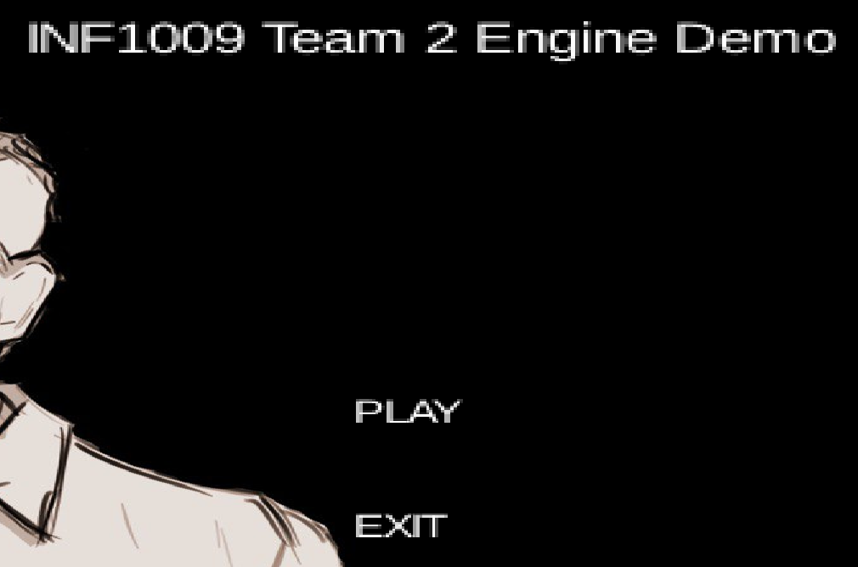
In terms of menu screen limitations, with just the barebone abstract engine, having fade-ins and transitions require more coding and a brief concept of how the application would run for its own purpose. Additionally, the engine design only involves manually computing button bounding boxes, drawing text, and checking clicks. This means you don’t automatically get hover states, button states (like pressed, disabled), tooltips, or any of the higher-level controls you’d get from a dedicated UI library (e.g., LibGDX’s Scene2D UI). Lastly, we noticed that the libgdx library does not have high quality text as seen in this figure below, LibGDX comes with a built-in BitmapFont that is not scalable. When you scale it up (font.getData().setScale(...)), you can see pixelation or blurriness.

Fig 2. Start Screen

Collision and Movement Management
Currently, our collision detection is only checked and handled using simple rectangular boundaries set by each object, which can lead to limited use cases. As a result, we might find it difficult to implement more complex gameplay elements which require more precise collision detection outside of rectangular shapes. Our simple handling also means that collision is done in a “brute-force” method, where the colliding object is placed back into its previous position, which means that it is not taking into account any other factors we might implement in the future such as momentum or physics. Additionally, our code is currently unable to handle multiple instances of collision with several objects, which might pose an issue when implementing
gameplay in the future.
A similar issue arises with our movement manager where the code is very simple and is not able to handle complex mechanics like acceleration or physics, and it is not able to create movement outside of the strict axis and or even path making.
However, we plan to implement the use of Box2d tools in LibGDX to code our collision and movement manager when we start work on our game, which should create a more sophisticated system.

Entity Management
One limitation with our Entity Manager is that it does not inherently contain ways to keep track of the status of the added and removed by it. An example would be our player class, which is initiated separately between each scene, but they remain as separate entities. This might complicate things when we want to implement gameplay elements like health and inventory in the future where they are required to persist even if they were to move between screens, or be removed temporarily.

Overview
As a foundational engine, I believe that the simple implementation methods are sufficient for our means and a starting point for our game. However, as we begin to idealise more complex scenarios that each manager might need to handle, we can modify the code in order to take into account different mechanics. Therefore, although our simple design might be a limiting factor currently, I believe that our efficient structuring means that we are not pigeon-holed into the linear code we have written so far.

Team member’s contribution
Name | Work Done
Wei Loong | Every Manager & Management
Abbie | I/O Management
Brian | Screen Manager
Aaron | Movement Manager
Jing Wen | Entity Manager
Daryl | Collision Manager

